Earth Day Rally!
MUSIC FESTIVAL & Tri-tip bbq
“Coming Together to Support the Environment and
Quality of Life for Nipomo and the Central Coast”

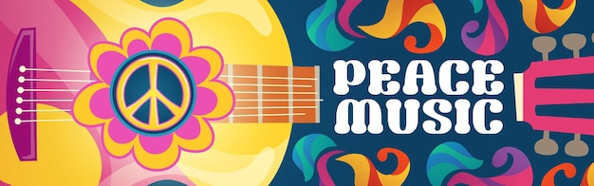
Saturday, April 22, 12pm-4pm
Nipomo Community Park-Gazebo

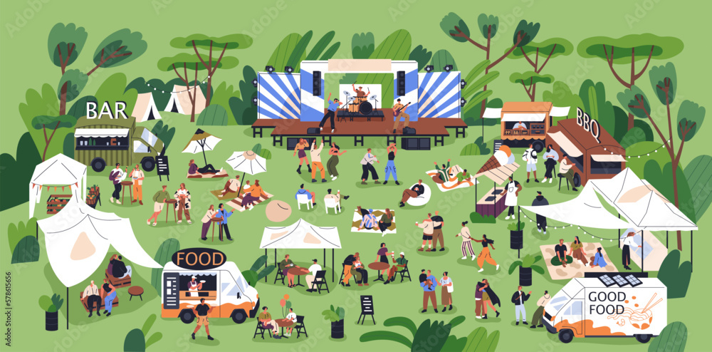
Entertainment & Fun for Everyone!
- Live Local Music from ‘Bridges’ & ‘Crooked Tree’
- Delicious Tri-Tip BBQ!
- Dynamic Speakers will address health, safety and impacts on our water, air, traffic, and native habitat.
- Welcome All! Family, Friends & Neighbors. Bring Blankets & Lawn Chairs!

Sponsored by The Nipomo Action Committee (NAC) for the Purpose of Raising Awareness & Resources toward Responsible, Sustainable Development for Nipomo!
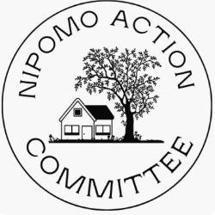
NAC a local non-profit, grassroots organization whose mission is to empower residents and provide a voice and resources in the matter of current and future development projects for Nipomo. We stand for responsible land use while preserving and maintaining the unique biodiversity historical, and cultural heritage that Nipomo and the Central Coast have to offer, now, and for generations to come.

For more information to attend, donate or to lend a hand:
www.stopdanareserve.com Nipomoaction@gmail.com
TAKE ACTION! Sign the petition, donate, make your voice count!
The Nipomo Action Committee is a fiscally sponsored organization of Ecologistics, Inc. A California 501(c)(3) nonprofit corporation. Donations are tax-deductible.

